MANUAL U-FISH FOR THAI OAF SKED
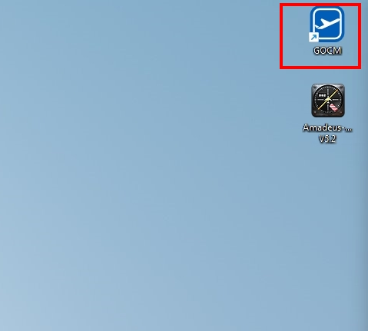
STEP 1) OPEN THE GOCM APPLICATION

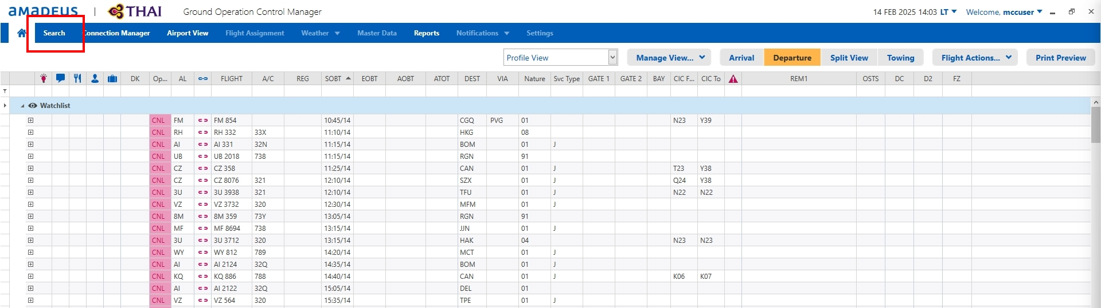STEP 2) CLICK SEARCH BUTTON ON THE TOP LEFT HAND SIDE
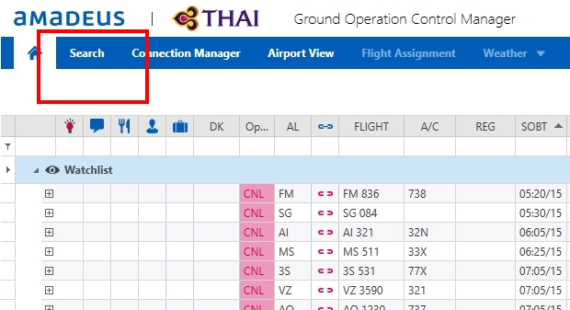
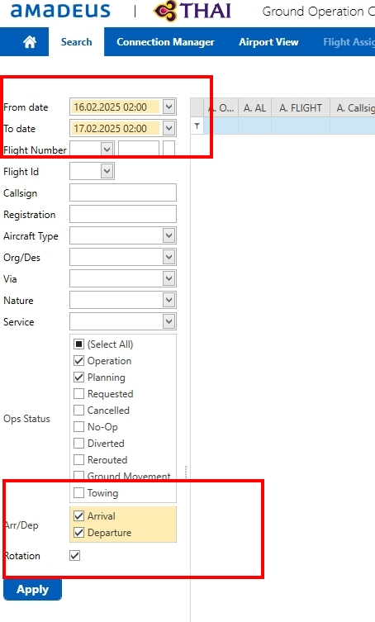STEP 3) SELECT FROM DATE AND TO THAT YOU’RE GOING TO DO
AND SELECT TIME AS 02:00 BOTH OF FROM DATE/ TO DATE
EXAMPLE: วันนี้วันที่ 15 FEB 2025 .ให้เลือก FROM DATE = 16.02.2025 02:00
TO DATE ให้เป็น 17.02.2025 02:00
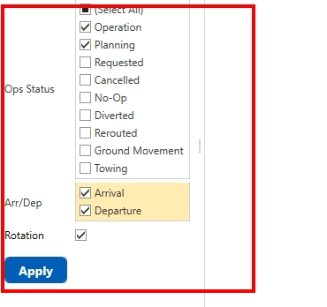STEP 4) SELECT OPERATION &PLANNING& ARRIVAL & DEPARTURE AND ROTATION THEM CLICK APPLY

STEP 5) TYPE “TG” ON THE “D.AL” THEN CLICK SORT DATA WITH “D.SOBT” FOR THE FIRST STEP, AND THE CLICK SORT “A.SIBT” FOR THE SECOND STEP. YOU MAY HAVE THE DATA FORM AS SAME AS THE PICTURE
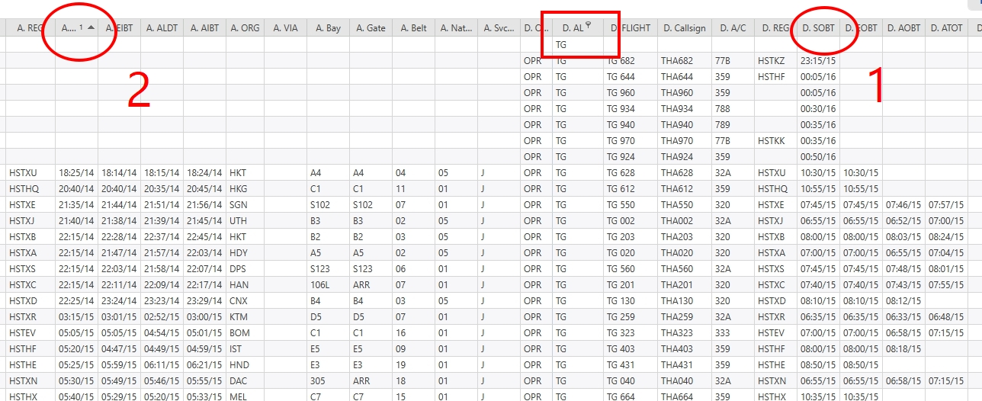

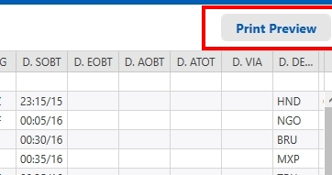STEP 6) CLICK ON “PRINT PREVIEW” BUTTON

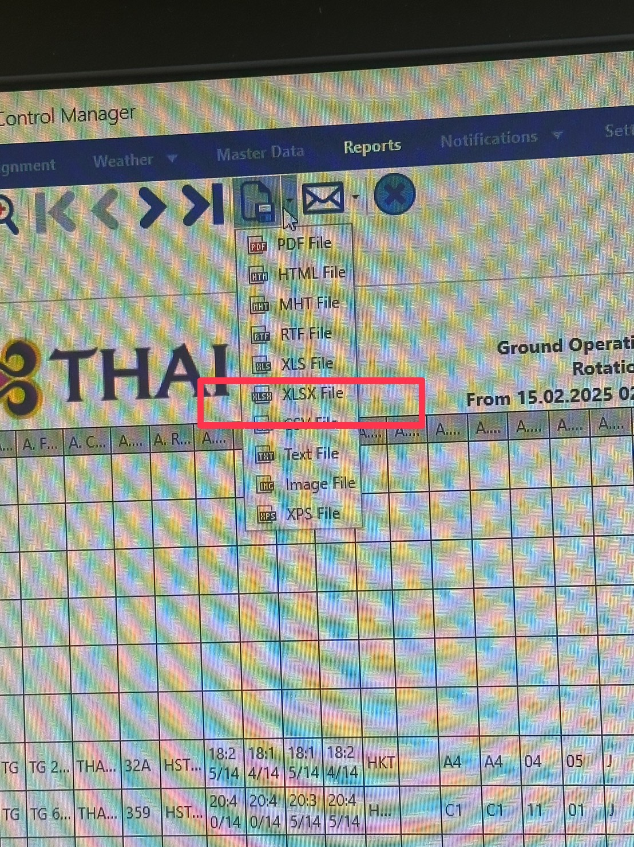STEP 7) CLICK DOWNLOAD FILE AS “XLSX.FILE”

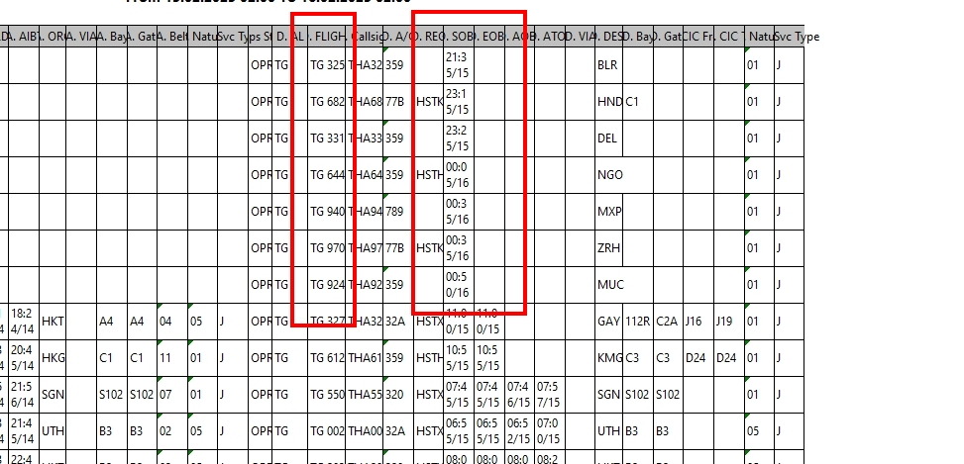STEP 8) OPEN THE FILE AND COPY THE COLUME AND PASTE IN THE FORMULAR SAME AS THE PICTURE **ไฟท์ขาออก**
UPDATE **เลือกไฟท์จนถึงก่อนตี3** (ดูเวลาจากไฟท์ขาเข้า)
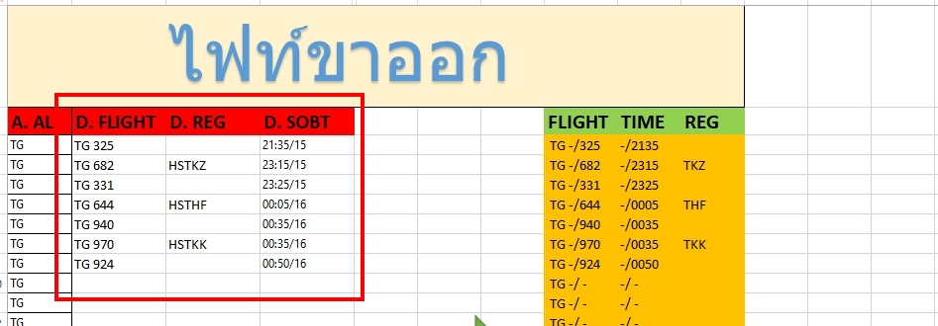

STEP 9) GO BACK TO “U-FISH” CLICK OUT THE “ROTATION” BUTTON
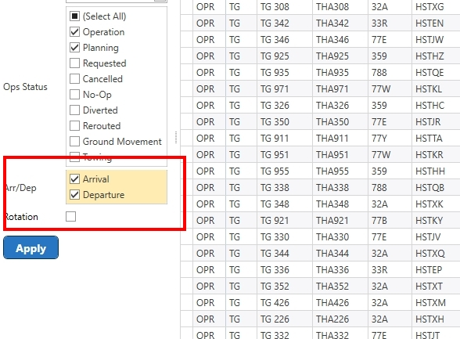
STEP 10) TYPE “TG” ON THE “A.AL” THEN CLICK A.SBIT FOR SORT THE TIME FOLLOWING AS THE PICTURE.
THEN DOWNLOAD FILE AS “XLSX.FILE” SAME AS “STEP 7”
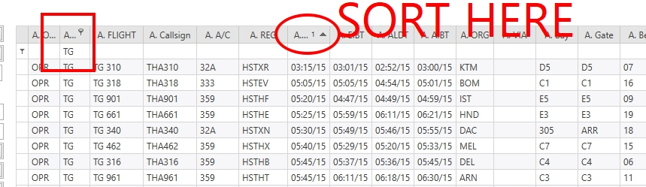

STEP 11) COPY THE DATA FROM U-FISH EXCEL AND PASE IN FORMULAR EXCLE FOLLOWING THE NUMBER SAME AS THE PICTURE
**SKED THAI**
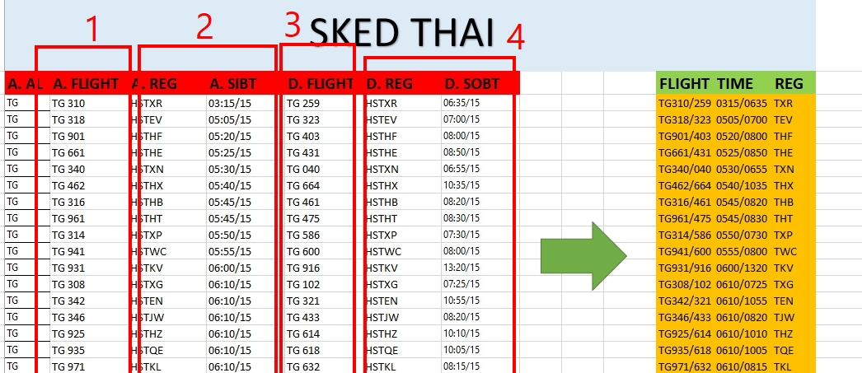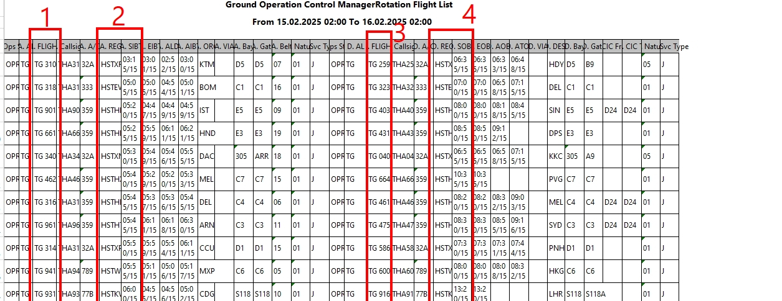

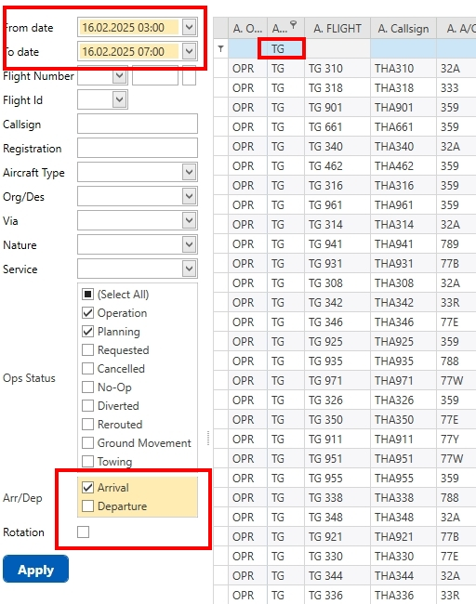STEP 12) CHANGE THE TIME ON “FROM DATE & TO DATE” AS 03:00 AND 07:00, AND CLICK SEARCH ONLY ARRIVAL, AND THEN DOWNLOAD FILE AS “XLSX.FILE” SAME AS “STEP 7”
**ให้เลือกวันที่เป็นวันมะรืน** **ไฟท์ขาเข้าวันรุ่งขึ้น**
BE CAREFUL THE COLUME “A.AL” IS “TG”

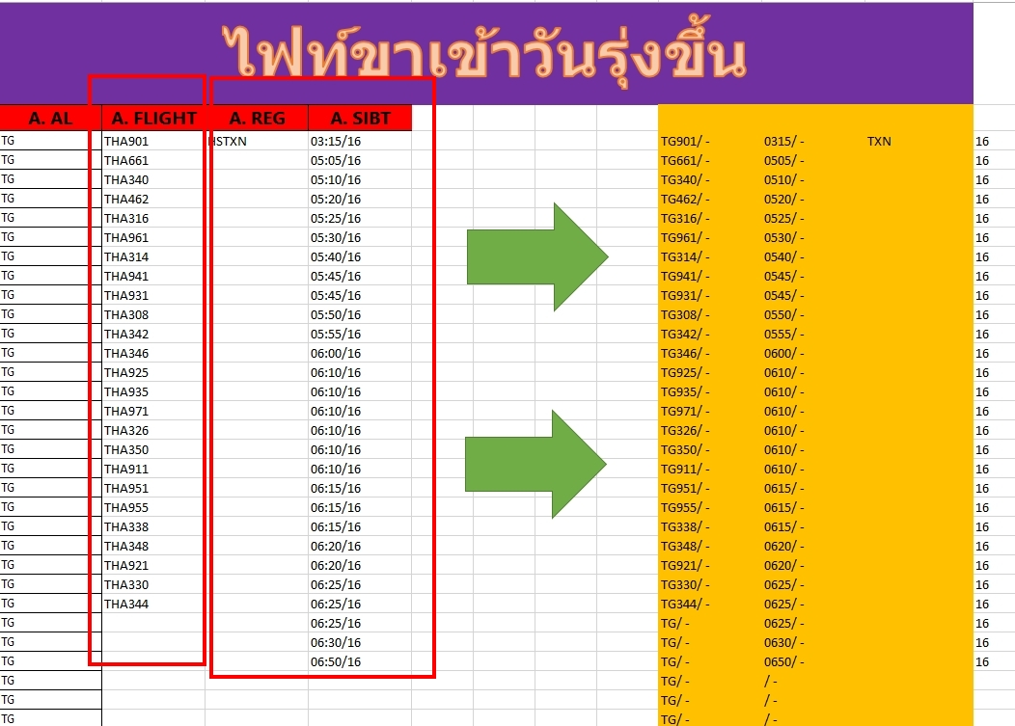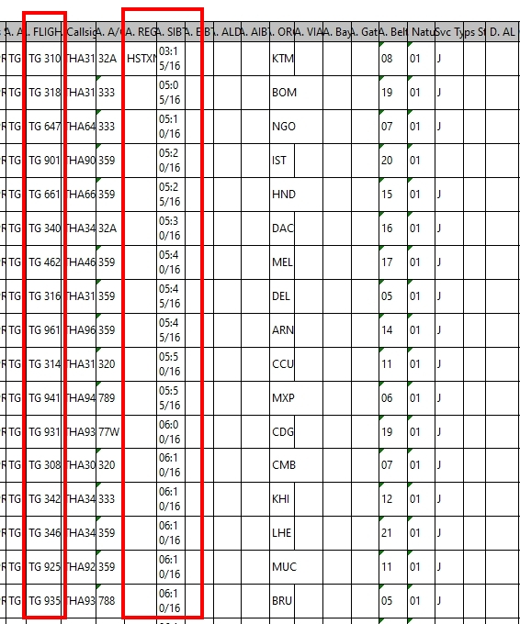STEP 13) OPEN THE FILE AND COPY THE COLUME AND PASTE IN THE FORMULAR SAME AS THE PICTURE **ไฟท์ขาเข้าวันรุ่งขึ้น**

